CS251 Statistical Computing

**HOP01C: Git and GitHub**

24/6/2020 Developed by Aya Khalil

10/16/2020 Reviewed by Shanshan Yu

School of Technology & Computing @City University of Seattle (CityU)



**Learning Outcomes**

* Understand the concept of version control system (VCS)
* Create GitHub account
* Create GitHub repository
* Use Git, GitHub
* Do 1 add, commit and push git operation

**Before you start**

Version control system (VCS) is created to makes it easy to store different versions of the project you are working at any time (without any fixed rules, time or rules). You can easily restore an earlier record and compare the content with the current data to find the differences. In addition, it also an effective tool to cooperate with many other people in the same project. In this module, we will learn about one of the most popular VCS which is Git and GitHub.

First of all, Git and GitHub are not the same thing. Git is a VCS while GitHub is a hosting server for software development version control. The way Git works is that it creates a **repository** to store each version of the project every time developers modify or add some features into the project. Developers use Git through terminal or command line.

However, Git only allows you to control your project version on your local machine. Therefore, if there are 2 or more people working on a same project, how do we connect the works of all the members? That is why we need a hosting server GitHub.

To learn more about Git and GitHub visit:

<https://codeburst.io/git-and-github-in-a-nutshell-b0a3cc06458f>

<https://git-scm.com/book/en/v1/Getting-Started-Git-Basics>

<https://www.youtube.com/watch?v=SWYqp7iY_Tc>

**Registering a GitHub account and GitHub repository (If you already have a GitHub account, skip to step 7)**

1. Visit <https://github.com/> and click on “Sign up for GitHub”

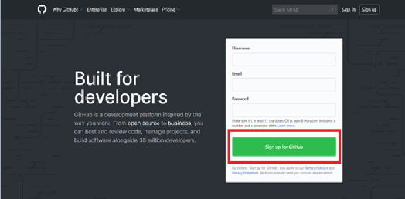

1. Filling in the form with Username, Email Address, Password and etc. It is very straightforward.

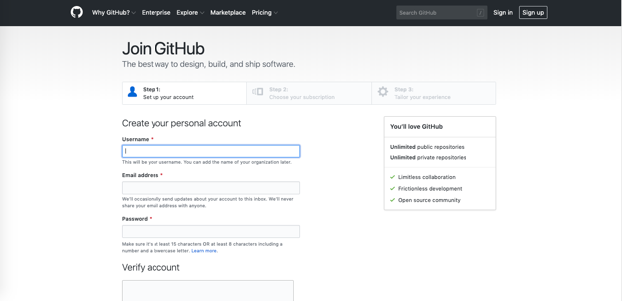

1. Click “Create Account” to proceed to next page
2. On Step 2, Choose your subscription as “Free” and click “Continue”

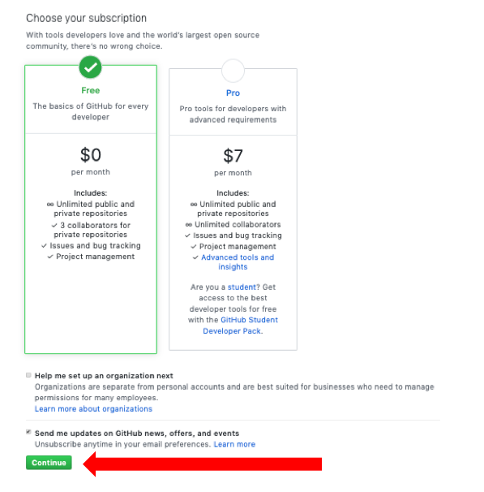

1. On Step 3, just be honest and choose your options then click “Submit” or you can just click on ‘skip this step’

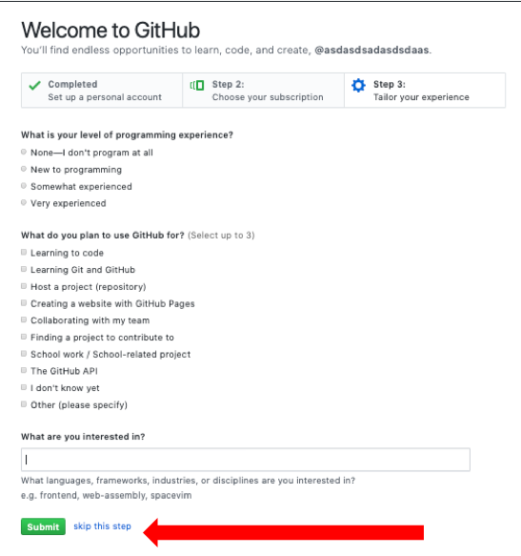

1. After that, you will be asked to check your email and verify your GitHub account
2. Go to github.com and login to your GitHub account.
3. Please submit your username to GitHub owner / maintainer.